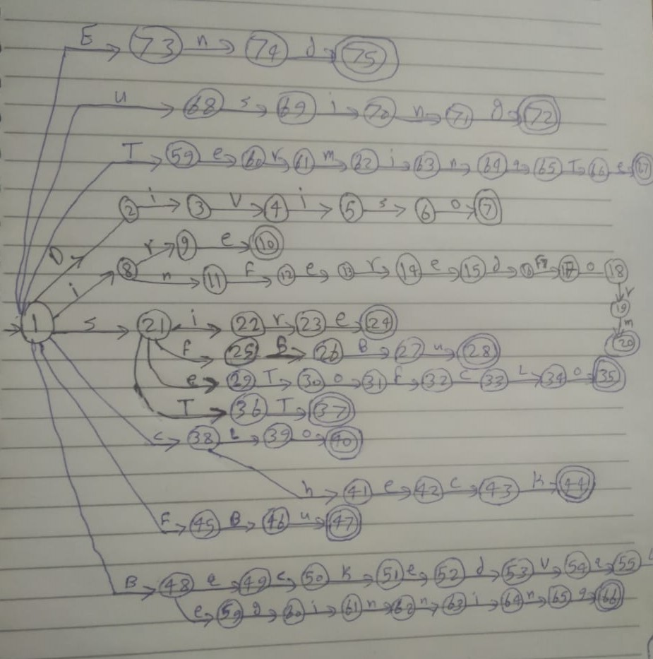

**Lexemes**

**Transactions Tables :**

|  |  |  |  |  |  |  |  |  |  |  |  |  |  |  |  |  |  |  |  |  |  |
| --- | --- | --- | --- | --- | --- | --- | --- | --- | --- | --- | --- | --- | --- | --- | --- | --- | --- | --- | --- | --- | --- |
| **V** | **U** | **T** | **S** | **R** | **Q** | **P** | **O** | **N** | **M** | **L** | **K** | **I** | **H** | **G** | **F** | **E** | **D** | **C** | **B** | **A** |  |
|  | **68** | **59** | **21** |  |  |  |  |  |  |  |  | **8** |  |  | **45** | **73** | **2** | **38** | **48** |  | **1** |
|  |  |  |  |  |  |  |  |  |  |  |  | **3** |  |  |  |  |  |  |  |  | **2** |
|  |  |  |  |  |  |  |  |  |  |  |  |  |  |  |  |  |  |  |  |  | **3** |
|  |  |  |  |  |  |  |  |  |  |  |  | **5** |  |  |  |  |  |  |  |  | **4** |
|  |  |  | **6** |  |  |  |  |  |  |  |  |  |  |  |  |  |  |  |  |  | **5** |
|  |  |  |  |  |  |  | **7** |  |  |  |  |  |  |  |  |  |  |  |  |  | **6** |
|  |  |  |  |  |  |  |  |  |  |  |  |  |  |  |  |  |  |  |  |  | **7** |
|  |  |  |  | **9** |  |  |  | **11** |  |  |  |  |  |  |  |  |  |  |  |  | **8** |
|  |  |  |  |  |  |  |  |  |  |  |  |  |  |  |  | **10** |  |  |  |  | **9** |
|  |  |  |  |  |  |  |  |  |  |  |  |  |  |  |  |  |  |  |  |  | **10** |
|  |  |  |  |  |  |  |  |  |  |  |  |  |  |  | **12** |  |  |  |  |  | **11** |
|  |  |  |  |  |  |  |  |  |  |  |  |  |  |  |  | **13** |  |  |  |  | **12** |
|  |  |  |  | **14** |  |  |  |  |  |  |  |  |  |  |  |  |  |  |  |  | **13** |
|  |  |  |  |  |  |  |  |  |  |  |  |  |  |  |  | **15** |  |  |  |  | **14** |
|  |  |  |  |  |  |  |  |  |  |  |  |  |  |  |  |  | **16** |  |  |  | **15** |
|  |  |  |  |  |  |  |  |  |  |  |  |  |  |  | **17** |  |  |  |  |  | **16** |
|  |  |  |  |  |  |  | **18** |  |  |  |  |  |  |  |  |  |  |  |  |  | **17** |
|  |  |  |  | **19** |  |  |  |  |  |  |  |  |  |  |  |  |  |  |  |  | **18** |
|  |  |  |  |  |  |  |  |  | **20** |  |  |  |  |  |  |  |  |  |  |  | **19** |
|  |  |  |  |  |  |  |  |  |  |  |  |  |  |  |  |  |  |  |  |  | **20** |
|  |  |  |  |  |  |  |  |  |  |  |  |  |  | **22** | **25** | **26** |  |  |  |  | **21** |
|  |  |  |  | **23** |  |  |  |  |  |  |  |  |  |  |  |  |  |  |  |  | **22** |
|  |  |  |  |  |  |  |  |  |  |  |  |  |  |  |  | **24** |  |  |  |  | **23** |
|  |  |  |  |  |  |  |  |  |  |  |  |  |  |  |  |  |  |  |  |  | **24** |
|  |  |  |  |  |  |  |  |  |  |  |  |  |  |  |  |  |  |  | **26** |  | **25** |
|  |  |  |  |  |  |  |  |  |  |  |  |  |  |  |  |  |  |  | **27** |  | **26** |
|  | **28** |  |  |  |  |  |  |  |  |  |  |  |  |  |  |  |  |  |  |  | **27** |
|  |  |  |  |  |  |  |  |  |  |  |  |  |  |  |  |  |  |  |  |  | **28** |
|  |  | **30** |  |  |  |  |  |  |  |  |  |  |  |  |  |  |  |  |  |  | **29** |
|  |  |  |  |  |  |  | **31** |  |  |  |  |  |  |  |  |  |  |  |  |  | **30** |
|  |  |  |  |  |  |  |  |  |  |  |  |  |  |  | **32** |  |  |  |  |  | **31** |
|  |  |  |  |  |  |  |  |  |  |  |  |  |  |  |  |  |  | **33** |  |  | **32** |
|  |  |  |  |  |  |  |  |  |  | **34** |  |  |  |  |  |  |  |  |  |  | **33** |
|  |  |  |  |  |  |  | **35** |  |  |  |  |  |  |  |  |  |  |  |  |  | **34** |
|  |  |  |  |  |  |  |  |  |  |  |  |  |  |  |  |  |  |  |  |  | **35** |
|  |  | **37** |  |  |  |  |  |  |  |  |  |  |  |  |  |  |  |  |  |  | **36** |
|  |  |  |  |  |  |  |  |  |  |  |  |  |  |  |  |  |  |  |  |  | **37** |
|  |  |  |  |  |  |  |  |  |  | **39** |  |  | **41** |  |  |  |  |  |  |  | **38** |
|  |  |  |  |  |  |  | **40** |  |  |  |  |  |  |  |  |  |  |  |  |  | **39** |
|  |  |  |  |  |  |  |  |  |  |  |  |  |  |  |  |  |  |  |  |  | **40** |
|  |  |  |  |  |  |  |  |  |  |  |  |  |  |  |  | **42** |  |  |  |  | **41** |
|  |  |  |  |  |  |  |  |  |  |  |  |  |  |  |  |  |  | **43** |  |  | **42** |
|  |  |  |  |  |  |  |  |  |  |  | **44** |  |  |  |  |  |  |  |  |  | **43** |
|  |  |  |  |  |  |  |  |  |  |  |  |  |  |  |  |  |  |  |  |  | **44** |
|  |  |  |  |  |  |  |  |  |  |  |  |  |  |  |  |  |  |  | **46** |  | **45** |
|  | **47** |  |  |  |  |  |  |  |  |  |  |  |  |  |  |  |  |  |  |  | **46** |
|  |  |  |  |  |  |  |  |  |  |  |  |  |  |  |  |  |  |  |  |  | **47** |
|  |  |  |  |  |  |  |  |  |  |  |  |  |  |  |  |  |  |  |  | **49** | **48** |
|  |  |  |  |  |  |  |  |  |  |  |  |  |  |  |  |  |  | **50** |  |  | **49** |
|  |  |  |  |  |  |  |  |  |  |  | **51** |  |  |  |  |  |  |  |  |  | **50** |
|  |  |  |  |  |  |  |  |  |  |  |  |  |  |  |  | **52** |  |  |  |  | **51** |
|  |  |  |  |  |  |  |  |  |  |  |  |  |  |  |  |  | **53** |  |  |  | **52** |
| **54** |  |  |  |  |  |  |  |  |  |  |  |  |  |  |  |  |  |  |  |  | **53** |
|  |  |  |  |  |  |  |  |  |  |  |  |  |  |  |  |  |  |  |  | **55** | **54** |
|  |  |  |  |  |  |  |  |  |  | **56** |  |  |  |  |  |  |  |  |  |  | **55** |
|  | **57** |  |  |  |  |  |  |  |  |  |  |  |  |  |  |  |  |  |  |  | **56** |
|  |  |  |  |  |  |  |  |  |  |  |  |  |  |  |  | **58** |  |  |  |  | **57** |
|  |  |  |  |  |  |  |  |  |  |  |  |  |  |  |  |  |  |  |  |  | **58** |
|  |  |  |  |  |  |  |  |  |  |  |  |  |  | **60** |  |  |  |  |  |  | **59** |
|  |  |  |  |  |  |  |  |  |  |  |  | **61** |  |  |  |  |  |  |  |  | **60** |
|  |  |  |  |  |  |  |  | **62** |  |  |  |  |  |  |  |  |  |  |  |  | **61** |
|  |  |  |  |  |  |  |  | **63** |  |  |  |  |  |  |  |  |  |  |  |  | **62** |
|  |  |  |  |  |  |  |  |  |  |  |  | **64** |  |  |  |  |  |  |  |  | **63** |
|  |  |  |  |  |  |  |  | **65** |  |  |  |  |  |  |  |  |  |  |  |  | **64** |
|  |  |  |  |  |  |  |  |  |  |  |  | **66** |  |  |  |  |  |  |  |  | **65** |
|  |  |  |  |  |  |  |  |  |  |  |  |  |  |  |  | **67** |  |  |  |  | **66** |
|  |  |  |  |  |  |  |  |  |  |  |  |  |  |  |  |  |  |  |  |  | **67** |
|  |  |  | **69** |  |  |  |  |  |  |  |  |  |  |  |  |  |  |  |  |  | **68** |
|  |  |  |  |  |  |  |  |  |  |  |  | **70** |  |  |  |  |  |  |  |  | **69** |
|  |  |  |  |  |  |  |  | **71** |  |  |  |  |  |  |  |  |  |  |  |  | **70** |

identifier = letter (letter |digit)*

digit = [0-9]

digit

Comment

RE = **/** ( **-**| **#** ) | **#/**

RE = **/# #/**  | **/-**

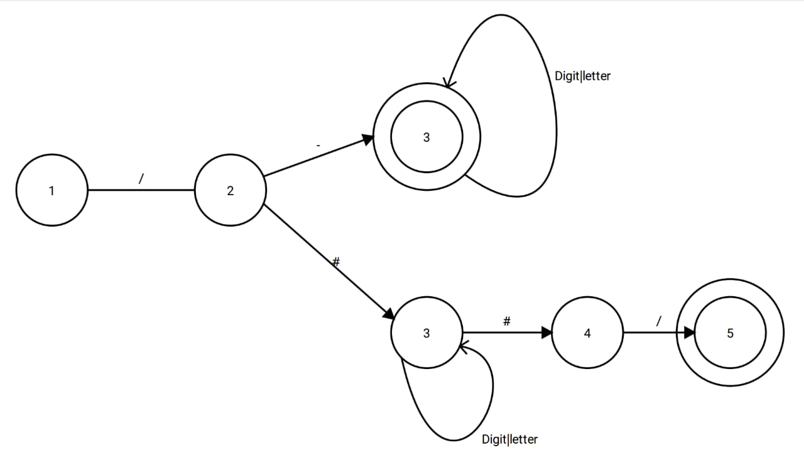

Symbols

+

Constant

RE = **Digit**+

Arithmetic Operations

RE = **+** | **-** | **\*** | **/**

**Delimiter And Logic operators:**

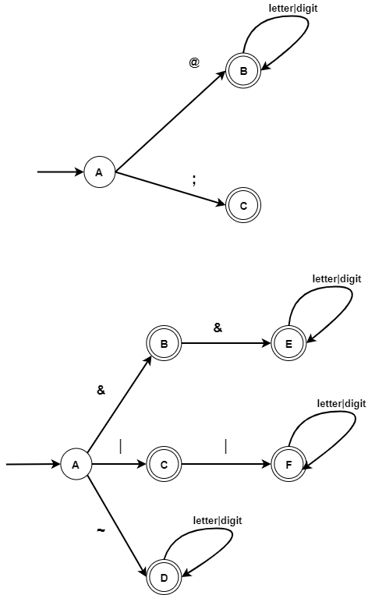

Logic Operators

RE = **&&** | **||** | **~**

Relational Operators

RE =( == | != | <= | >= | < | > )

Or

RE = ( **!** | **=** )**=** | ( **<** | **>** ) **=**